

**CLUB WELFARE OFFICER**

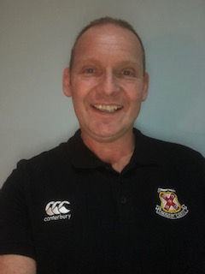

Name: Harry Faulkner

**Phone: 07894663027**

**Email: harryfaulknerrug@aol.co.uk**

|  |  |
| --- | --- |
| **Branch Welfare Officer**  Kerry Spence  0044 7767 168982  [kerry.spence@ulsterrugby.com](mailto:kerry.spence@ulsterrugby.com) | **IRFU Safeguarding Officer**  **Anne Marie Hughes:** [safeguarding@irfu.ie](mailto:safeguarding@irfu.ie) |

Visit: [www.irishrugby.ie/safeguarding](http://www.irishrugby.ie/safeguarding) or scan: